Michael Wilson
ME 476C
09/27/2020
Student Directed Self-Learning
The student self-directed learning assignment is designed to help students learn how to learn. As engineers we will always have to learn new skills as new problems and challenges arise throughout our careers. Therefore, it is an essential skill for students to know how to research and teach themselves new skills. The skill that I decided to teach myself is analysis for the aerodynamics of protuberance. I chose this skill because aerodynamics is a topic that I am not very knowledgeable in. This skill is relevant to the Northrop Grumman capstone project as any extrusions of the door design from the outer face of the launch vehicle will cause a change in the aerodynamic flow of the rocket. The main use of this skill in the scope of the capstone project is to verify that that the door design does not create any aerodynamic forces large enough to affect the flight of the vehicle.
The study began with building a basic understanding of aerodynamic forces and drag. Building a solid foundation is essential before diving in deeper into more complex analysis. The main force the door design would cause in respect to aerodynamic flight is the drag force. A basic analysis of drag is based on fluid density, cross-sectional area, velocity, and the drag coefficient [1]. Drag coefficients are constants to account for body shape, Reynold’s #, Froude #, Mach #, and surface roughness [2]. Having these basic parameters allow for an analysis of the overall drag force on an object. These basic equations will likely be the most useful to determine if the door affects aerodynamic forces of the vehicle. Figure 1 shows personal notes relevant to drag forces.
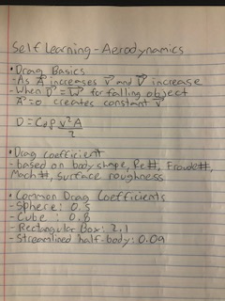
Figure 1: Notes on Basics of Aerodynamic Drag
Reference [3] is very relevant to the overall aerodynamics of protuberance, specifically applied to standard satellite launch vehicles. This is a direct application of what would be used for analysis on the Antares rocket. The article goes in depth about flow field analysis over protuberance for launch vehicles and the process for solving various parameters such as surface pressure coefficients, ascent trajectory, and protuberance forces. This is quite similar to analysis of the effect of all protuberance effects on the launch vehicle as a whole. Therefore, this analysis technique would likely be out of the scope of our capstone project but has potential use if it is determined that extrusions from the door designs cause noticeable difference in the aerodynamic forces of the rocket.
Applying this learned knowledge will be useful for the capstone project as it is essential to make sure there are no major alterations to the aerodynamics of the launch vehicle. I decided to apply this information by creating a MATLAB script to calculate a basic analysis of the drag force of any extrusions from the door design. This will allow the team to compare the drag force to the thrust loads of the vehicle and determine if there will be any major changes that could alter the flight of the vehicle. While creating the MATLAB code I made sure to have the layout clear, user-friendly, and provided clear comments for future reference to allow for changes to the code as necessary. Figure 2 shows the code for MATLAB that will allow the user to input values for each parameter and will receive an output of the calculated drag force.
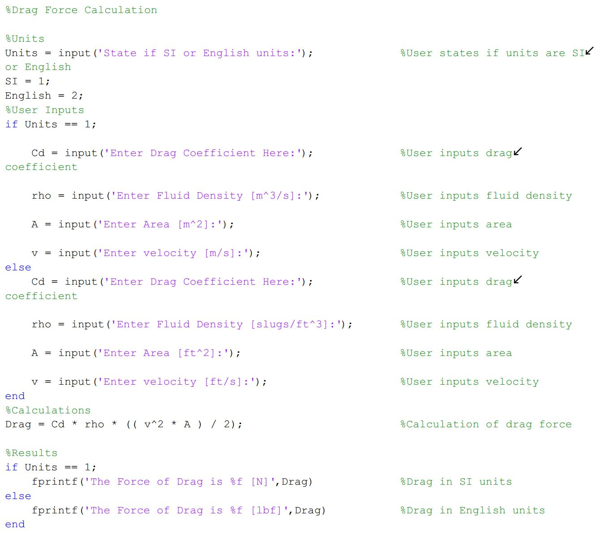
Figure 2: MATLAB Script
Learning how to automate and have digital tools for analysis is also an essential skill in engineering. Making programs in excel, MATLAB, or any other program can be used to help make calculations for design in a timely manner and can reduce potential for mistakes. That is why I chose to make a MATLAB program that can be saved and built upon to quickly do calculations for drag forces. This is a skill that I realized can be very useful during machine design with the use of excel to help automate calculation during spring and gear design. As engineers it is important to use our skills and knowledge to make sure our design and analysis is accurate, but also done in a timely manner when working in industry.
As a design is conceptualized for the door, I plan to use the MATLAB script to help the team determine whether the door will have any major affect on the aerodynamic forces of the vehicle. Based on this determination, I will build upon my MATLAB code to do an in-depth analysis on the effect of protuberance from the door will have on the launch vehicle. This in-depth analysis will allow the team to determine the best course of action and make changes as necessary.

References

[1] | N. Hall, "NASA Beginer's Guide To Aerodynamics," NASA, 5 May 2015. [Online]. Available: https://www.grc.nasa.gov/WWW/k-12/airplane/ffall.html. [Accessed 24 September 2020].
[2] | "Drag Coefficient," Engineering Toolbox, 2004. [Online]. Available: https://www.engineeringtoolbox.com/drag-coefficient-d_627.html. [Accessed 24 September 2020].
[3] | R. Mehta, "Computation of Aerodynamic load on Protuberance over Satellite Launch Vehicle at Supersonic Speed," Scholars Journal of Engineering and Technology, vol. 4, no. 7, pp. 301-307, 2016.

